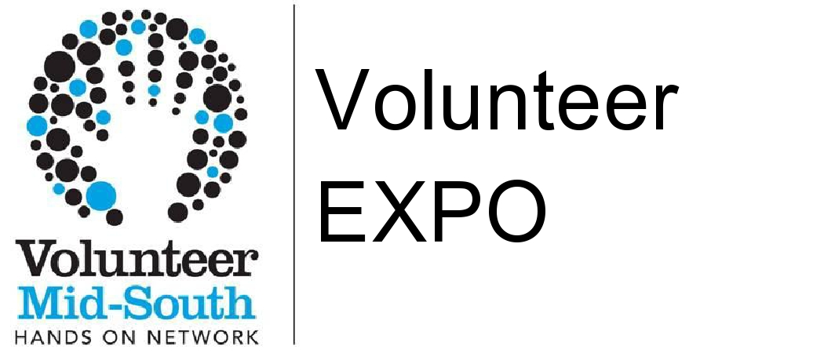
Volunteer Mid-South
3181 Poplar Ave., Suite 325 Memphis, TN 38111
Amanda Kiser
e-mail: akiser@volunteermidsouth.org
phone: 901-523-2425 ext.200
website: www.volunteermidsouth.org
FOR IMMEDIATE RELEASE

VOLUNTEER EXPO COMING FEBRUARY 19, 2013
Tuesday, February 19, 2013
3:30 PM - 6:30 PM
Oak Court Mall
MEMPHIS FEB. 12, 2013 --- Held in February of each year, the Volunteer Expo features over 75 nonprofit organizations showcasing their programs & volunteer opportunities. No matter who you are - you can find your perfect volunteering match at the Volunteer Expo!
Learn a lot about many unique opportunities and other ways to make a difference in our community. Visit with representatives from several Mid-South nonprofit organizations such as United Way, St. Jude, National Civil Rights Museum, Memphis In May and Salvation Army Kroc Center. The Volunteer Expo is a fun environment where you can ask questions and discover opportunities to give back as little as two hours or as much as two years.
Sponsored by Volunteer Mid-South, the Volunteer Expo will be held February 19 from 3:30-6:30 pm at the Oak Court Mall. The Expo is free and open to the public.
For more information, please visit www.volunteermidsouth.org or contact Amanda Kiser at akiser@volunteermidsouth.org or call 901-523-2425, ext. 200.
###
Volunteer Mid-South develops, promotes, and supports volunteerism.

